

**Green University of Bangladesh**

**Department of Computer Science and Engineering (CSE)**

**Faculty of Sciences and Engineering**

**Semester: (Spring, Year:2022), B.Sc. in CSE (Day)**

**LAB REPORT NO #1**

**Course Title: Structured Programming Lab**

**Course Code: CSE 104 Section: D3**

**Lab Experiment Name: Basic Structure and Syntax of**

**C Programming Language**

**Student Details**

| **Name** | | **ID** |
| --- | --- | --- |
| **1.** | **Md. Maruf Sarker** | **221002063** |

**Lab Date : 14-06-2022**

**Submission Date : 21-06-2022**

**Course Teacher’s Name : Ahmed Iqbal Pritom**

**[For Teachers use only: Don’t Write Anything inside this box]**

| **Lab Report Status**  **Marks: ………………………………… Signature:.....................**  **Comments:.............................................. Date:..............................** |
| --- |

**1. TITLE OF THE LAB EXPERIMENT**

Basic Structure and Syntax of C Programming Language

**2. OBJECTIVES/AIM [1]**

1. Print the sum of two int numbers
2. Print two int numbers
3. Take two int numbers from the user and print the sum of those numbers
4. Take two int numbers from the user and print the product of those numbers
5. Take two float numbers from the user and print the sum of those numbers

**3. PROCEDURE / ANALYSIS / DESIGN [2]**

**Task-1:**

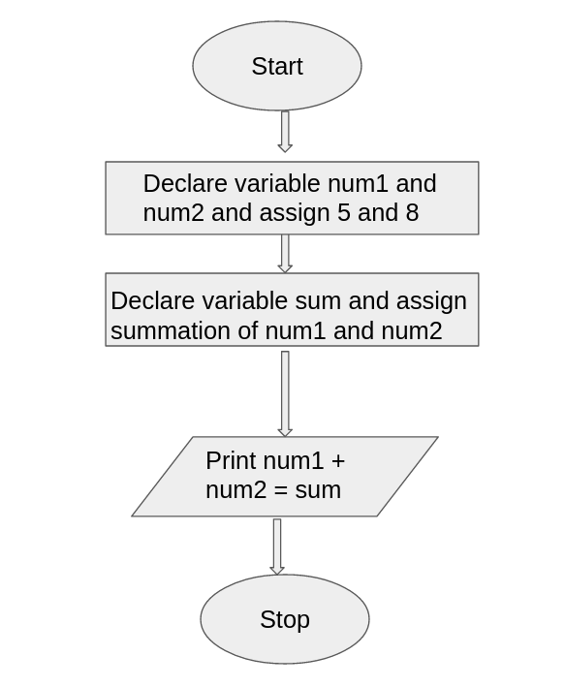

**Task-2:**

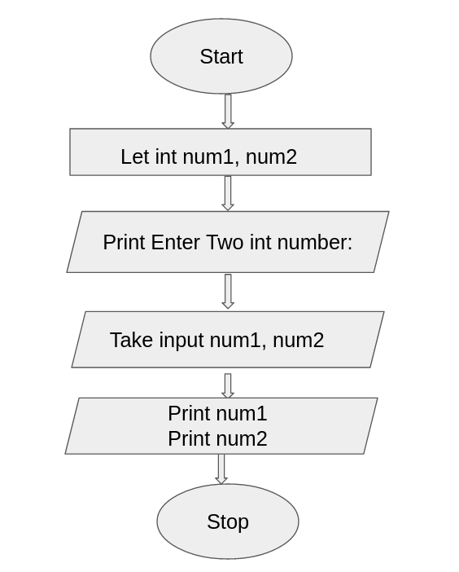

**Task-3:**

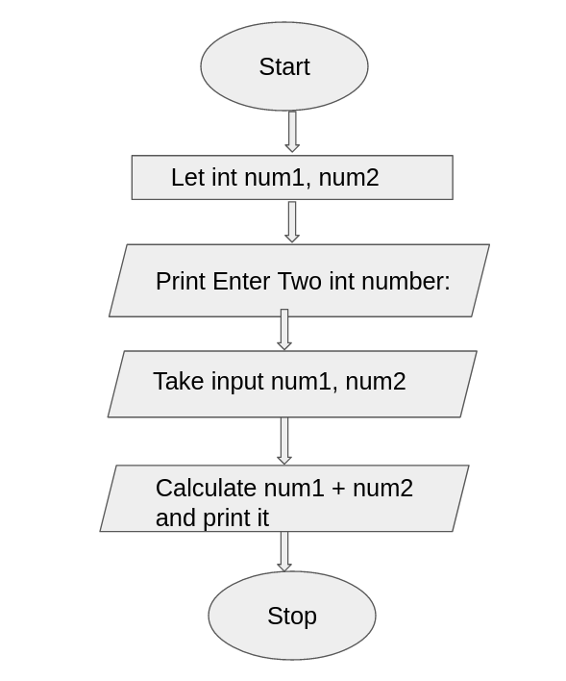

**Task-4:**

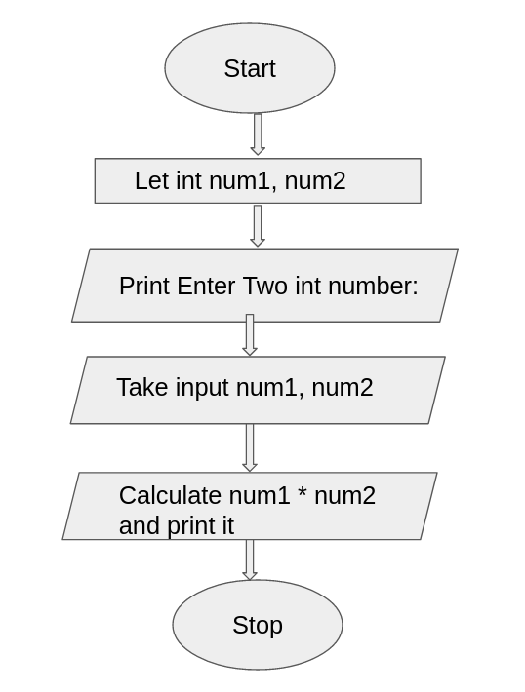

**Task-5:**

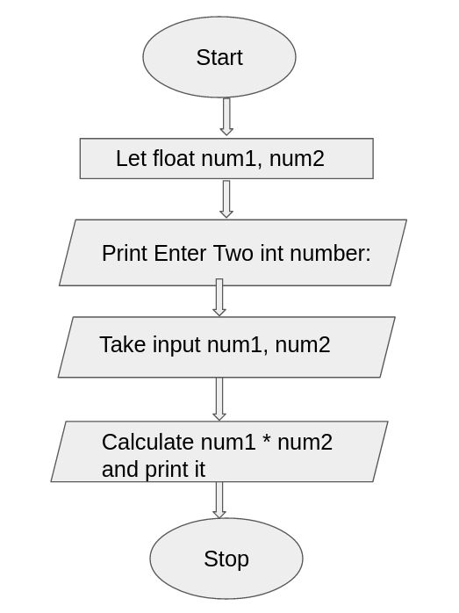

**4. IMPLEMENTATION [2]**

**Task-1:**

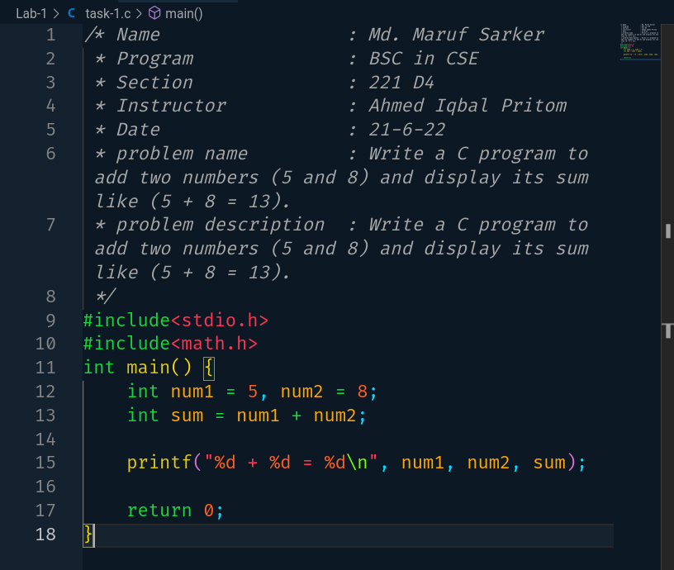

**Task-2:**

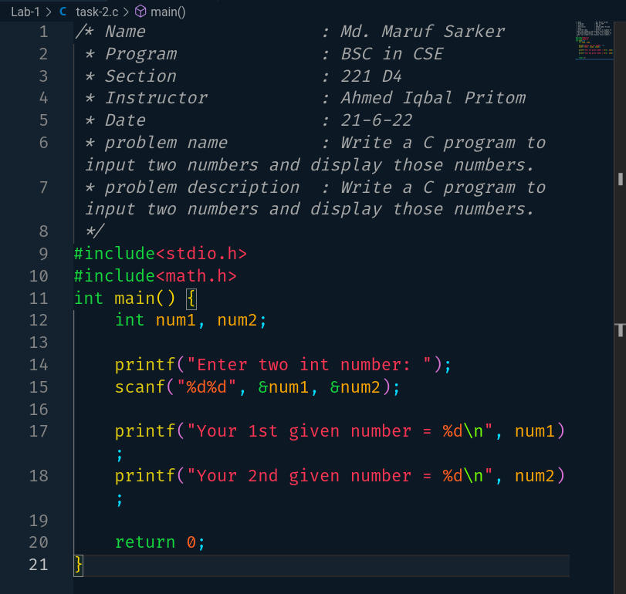

**Task-3:**

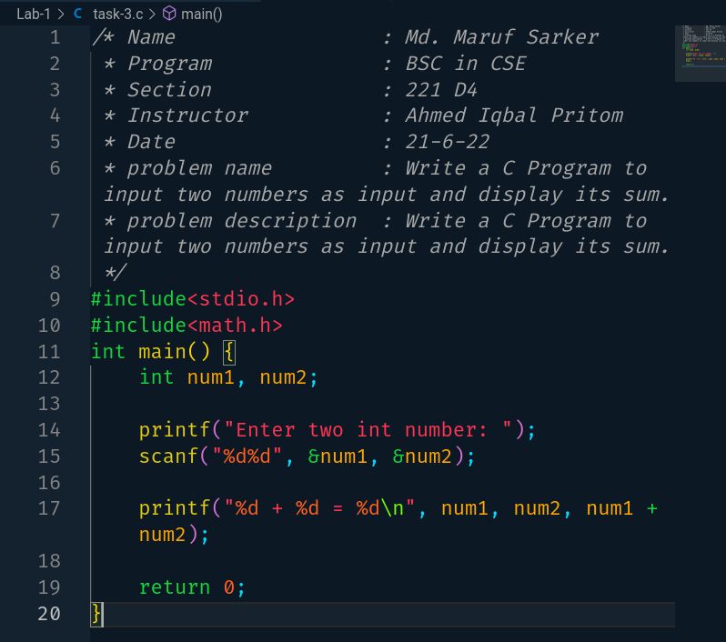

**Task-4:**

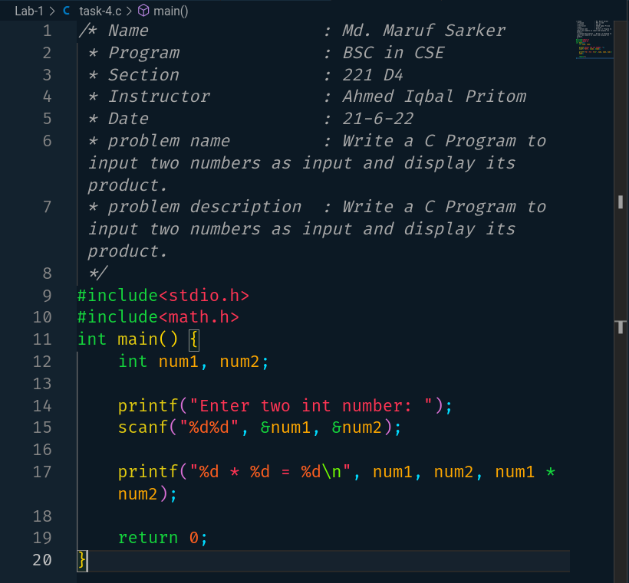

**Task-5:**

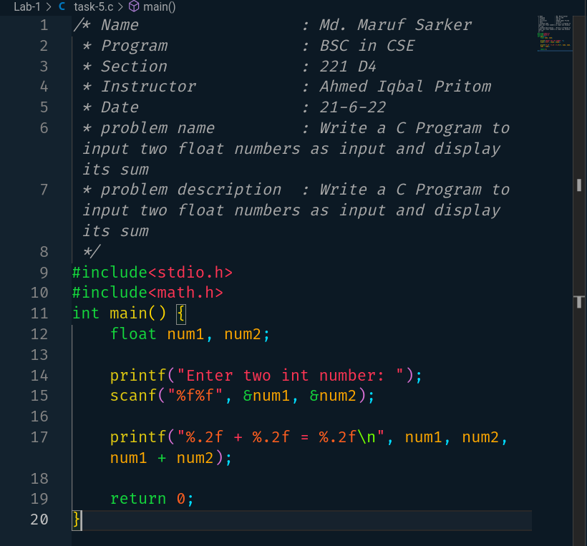

**5. TEST RESULT / OUTPUT [2]**

**Task-1:**

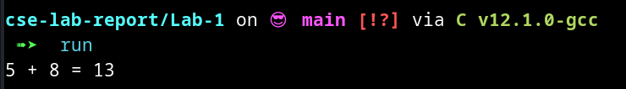

**Task-2:**

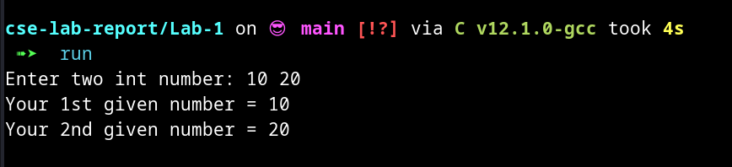

**Task-3:**

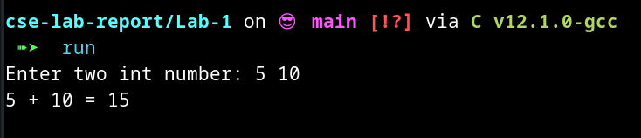

**Task-4:**

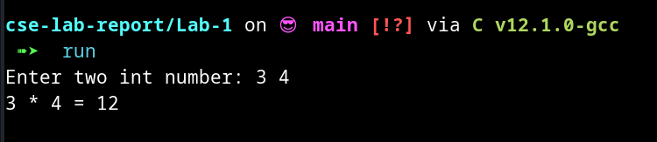

**Task-5:**

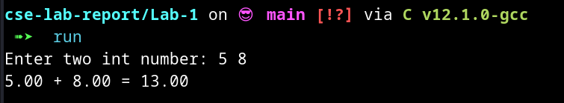

**6. ANALYSIS AND DISCUSSION [2]**

1. Everything is good. The output results in the previous section
2. Everything is interesting
3. I don’t face the trouble spots in completing this assignment
4. I don’t face the trouble spots in completing this assignment
5. It’s perfect and beginner-friendly
6. Assigning value into a variable, print any value in the terminal, take user input, calculate the sum of two int and calculate the product of two numbers, use new line, etc.
7. Can solve many arithmetic problems.